**Report 14**

**Part 1: Course exercises**

1.1: 词形还原

1.2: 词性标注

1.3: 停用词

1.4: NLTK

1.5: 精确

2.1: F

2.2: T

2.3: F

2.4: F

2.5: F

3.1: D

3.2: ABCD

3.3: D

3.4 A

3.5: B

4.1: 文本预处理的基本流程包括分词、词形统一化、删除停用词。

4.2:

1、 对文本进行分词操作，从中找出正向情感词、负向情感词、否定词以及程度副词。

2、判断每个情感词之前是否有否定词及程度副词，将它之前的否定词和程度副词划分为一组。如果存在否定词，则将情感词的情感权值乘以-1；如果有程度副词，就乘以程度副词的程度值。

3、将所有组的得分加起来，得分大于0的归于正向，小于0的归于负向。

**Part 2:**

**Re-implement the codes from the product evaluation analysis Demo in the text book page 249-253 summarize the results and screenshot the codes in the report.**

import jieba  
import pandas as pd  
from nltk import FreqDist  
from matplotlib import pyplot as plt  
from wordcloud import WordCloud  
  
file_path = open('./商品评价信息.csv')  
file_data = pd.read_csv(file_path)  
# print(file_data)  
file_data.drop(file_data[file_data['评价信息'] == '此用户没有填写评价。'].index,inplace=True)  
# print(file_data)  
  
cut_words = jieba.lcut(str(file_data['评价信息'].values),cut_all = False)  
print(cut_words)  
  
stop_path = open('./停用词表.txt',encoding='utf-8')  
stop_words =stop_path.read()  
  
new_data = []  
for word in cut_words :  
 if word not in stop_words :  
 new_data.append(word)  
  
print(new_data)  
  
freq_list = FreqDist(new_data)  
  
most_common_words = freq_list.most_common()  
print(most_common_words)  
  
font = r'C:\Windows\Fonts\STXINGKA.TTF'  
wc = WordCloud(font_path = font, background_color = 'white',width = 1000,height = 800).generate(" ".join(new_data))  
plt.imshow(wc)  
plt.axis('off')  
plt.show()

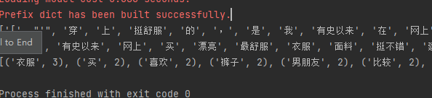  
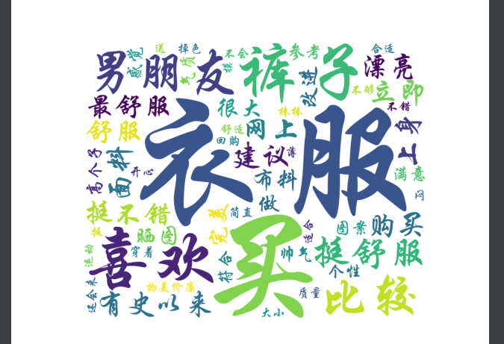

**Part 3:**

**从Moodle下载‘Report9-习近平在北京大学师生座谈会上的讲话.txt’文件并生成词云，具体方法参考本章节最后的实例以及网络资源，要求词云中不同频率的重点词语用不同颜色和字体大小进行显示，词云的形状要求贴合讲话内容，制作出的词云要求美观、大气、生动，*如果是动态词云可加分*.**

import jieba  
import matplotlib.pyplot as plt  
from wordcloud import WordCloud  
from collections import Counter  
from matplotlib.animation import FuncAnimation  
  
  
# 1. 文本预处理  
def process_text(file_path):  
 with open(file_path, 'r', encoding='utf-8') as f:  
 text = f.read()  
  
 # 清洗文本 - 移除换行符和多余空格  
 text = text.replace('\n', ' ').replace('\r', ' ').strip()  
  
 # 分词处理  
 words = jieba.lcut(text)  
  
 # 过滤单字  
 words = [word for word in words if len(word) > 1]  
  
 # 词频统计  
 word_freq = Counter(words)  
 return word_freq  
  
# 2. 动态词云生成  
def generate_dynamic_wordcloud(word_freq, output_path):  
 # 颜色函数  
 def random_color_func(word=None, font_size=None, position=None,  
 orientation=None, font_path=None, random_state=None):  
 h = random_state.randint(0, 360)  
 s = random_state.randint(70, 100)  
 l = random_state.randint(40, 70)  
 return f"hsl({h}, {s}%, {l}%)"  
  
 # 创建词云对象  
 wc = WordCloud(  
 font_path='simhei.ttf', # 使用黑体  
 background_color='white',  
 width=1000, # 设置画布宽度  
 height=700, # 设置画布高度  
 max_words=200,  
 max_font_size=150,  
 min_font_size=10,  
 color_func=random_color_func  
 )  
  
 # 生成词云  
 wc.generate_from_frequencies(word_freq)  
  
 # 创建图形  
 fig, ax = plt.subplots(figsize=(12, 8))  
 ax.axis('off')  
 img = ax.imshow(wc, interpolation='bilinear')  
  
 # 动画更新函数  
 def update(frame):  
 # 每帧改变颜色和旋转角度  
 current_wc = WordCloud(  
 font_path='simhei.ttf',  
 background_color='white',  
 width=1000,  
 height=700,  
 max_words=200,  
 max_font_size=150,  
 min_font_size=10,  
 color_func=random_color_func,  
 prefer_horizontal=0.9 - frame * 0.01 # 动态调整词语方向  
 )  
 current_wc.generate_from_frequencies(word_freq)  
 img.set_array(current_wc.to_array())  
 return [img]  
  
 # 创建动画  
 ani = FuncAnimation(fig, update, frames=30, interval=200, blit=True)  
  
 # 保存动态图  
 ani.save(output_path, writer='pillow', fps=5, dpi=300)  
 plt.close()  
  
  
# 3. 主程序  
if __name__ == "__main__":  
 # 参数设置  
 text_file = 'mao.txt'  
 output_gif = 'mao_speech_wordcloud.gif'  
  
 # 处理文本  
 word_freq = process_text(text_file)  
  
 # 生成动态词云  
 generate_dynamic_wordcloud(word_freq, output_gif)  
  
 print(f"动态词云已生成并保存为 {output_gif}")

